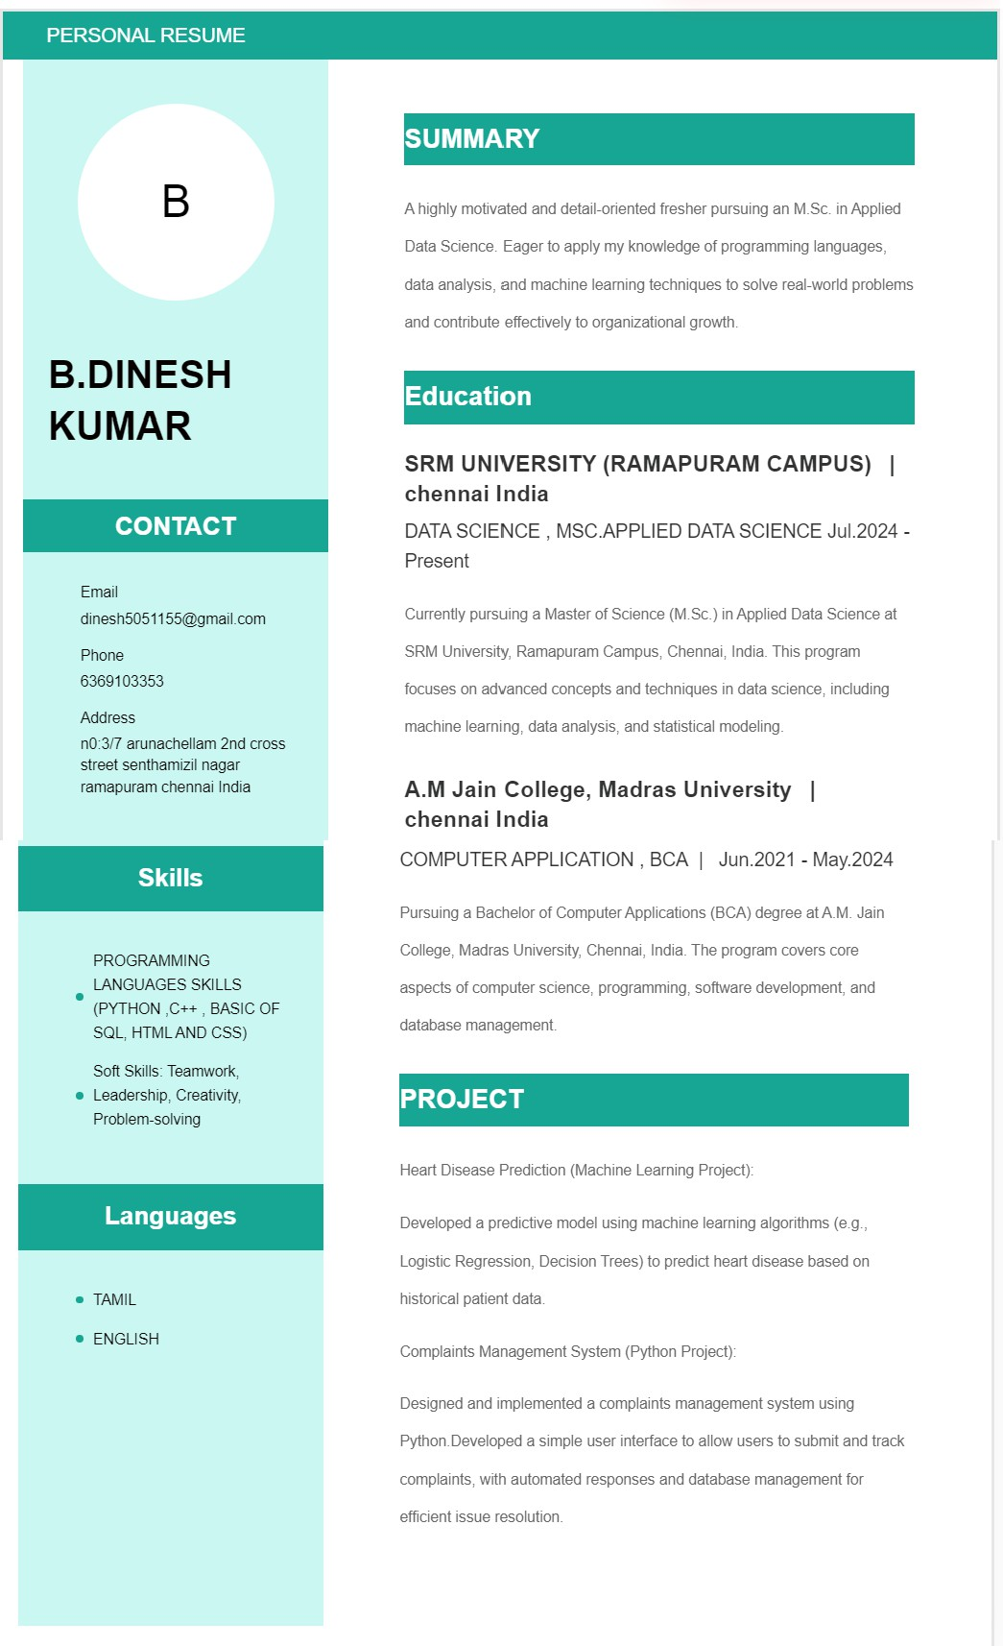

**INTERNSHIP**

**TOP TECH DEVELOPER**

* DOMAIN:

DATA ANALYSTICS (TRAINEE)